Diagram of a microscope
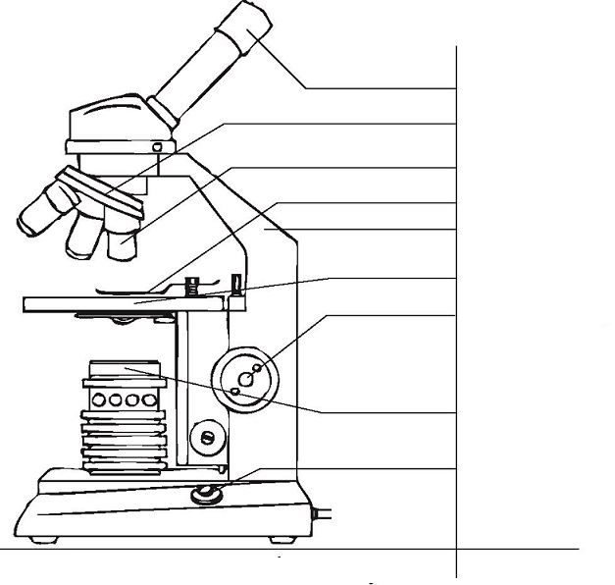

Feel the diagram, with the following words: arm of the microscope - course adjuster or course focus -eyepiece – electrical switch - light source - objective - small knob – stage - stage Clips -
Put your specimen on the stage

