**CALCUL DE COTE DE FABRICATION**

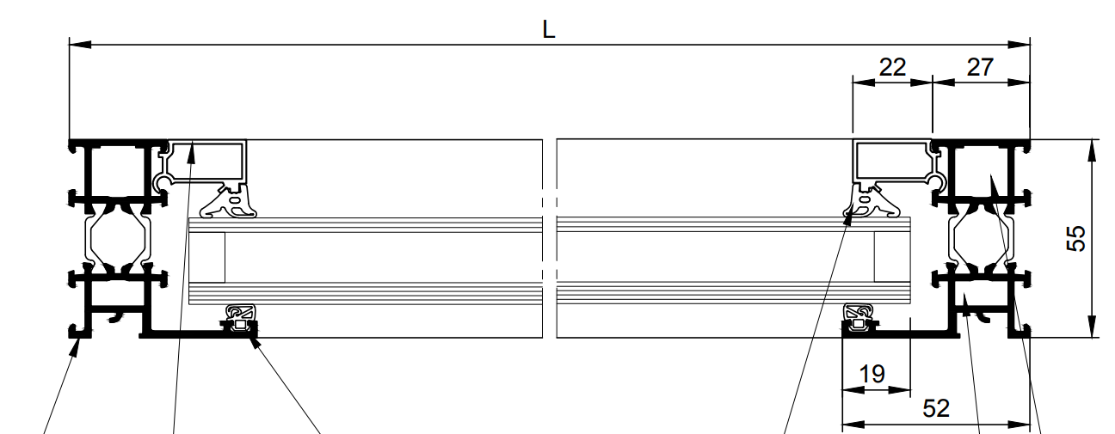

B

D

C

A

Sachant que L = 1200mm

Calculer A = L – 27 – 27 = 1200 – 27 -27 = 1146

Calculer b = L-52-52 = 1200-52-52=1096

Calculer C = L-27-27-22-22= 1200-27-27-22-22=1102

Calculer d = L -52 -52+19+19 = 1200-52-52+19+19=1134