**CALCUL DE COTE DE FABRICATION**

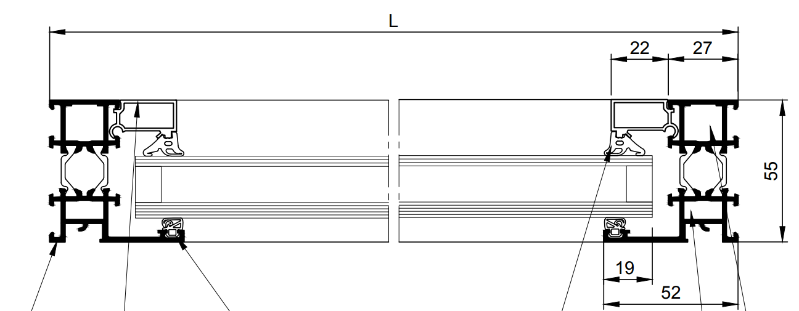

B

D

C

A

Sachant que L = 1200mm

Calculer A =

Calculer B =

Calculer C =

Calculer D =