***CALCUL DES MASSES DES DIFFERENTS VITRAGES***

***Masse verre simple*** : 4mm

Masse du verre (KG) = _ _ _ _ _ _ _ _ _ _ (M²) x _ _ _ _ _ _ _ _ _ _ (mm) x _ _ _ _ _ _

Exemple : Vitrage dimensions L = 1200mm l=800mm ep 4

Masse du vitrage = _ _ _ _ _ _ _ _ _ _ _ _ _ _ _ _ _ _ _ _ _ _ _ _ _ _ _ _ _ _ _ _ _

***Masse Verre feuilleté****:* 44.2

Ep verre 1 Ep verre 2 Nombre de films

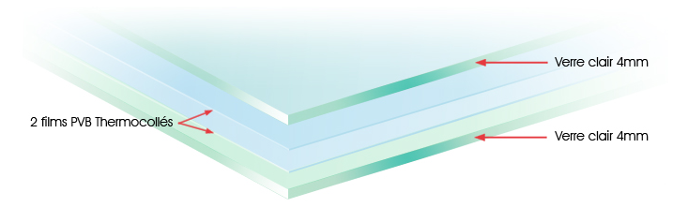

Ep = 0.38 mm

Masse surfacique = 0.5 kg / M²

Ep2

Ep1

Masse du verre (KG) = _ _ _ _ _ _ _ _ _ _ _ _ (M²) * [(_ _ _ _ _ _ _ _ + _ _ _ _ _ _ _ _ _ _) * _ _ _ _ + (_ _ _ _ _ _ * _ _ _ _) ]

Exemple : Vitrage dimensions L = 1400mm l=1800mm ep 44.3

Masse du vitrage = _ _ _ _ _ _ _ _ _ _ _ _ _ _ _ _ _ _ _ _ _ _ _ _ _ _ _ _ _ _ _ _ _ _ _ _ _ _ _ _ _ _ _ _ _ _ _

***Masse double vitrage*** : 4/16/4

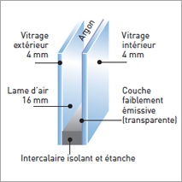

Masse du verre (KG) = _ _ _ _ _ _ _ _ _ (M²) * (_ _ _ _ _ + _ _ _ _ _ _ ) * _ _ _ _ _ _

Exemple : Vitrage dimensions L = 2400mm l=1800mm 4/16/4

Masse du vitrage = _ _ _ _ _ _ _ _ _ _ _ _ _ _ _ _ _ _ _ _ _ _ _ _ _ _ _ _ _ _ _ _ _ _ _ _ _ _ _ _ _ _ _ _ _ _ _